DSA06 DATA HANDLING AND VISUALIZATION
ACTIVITY: IDENTIFY SEASONALITY PATTERNS — SP-D24
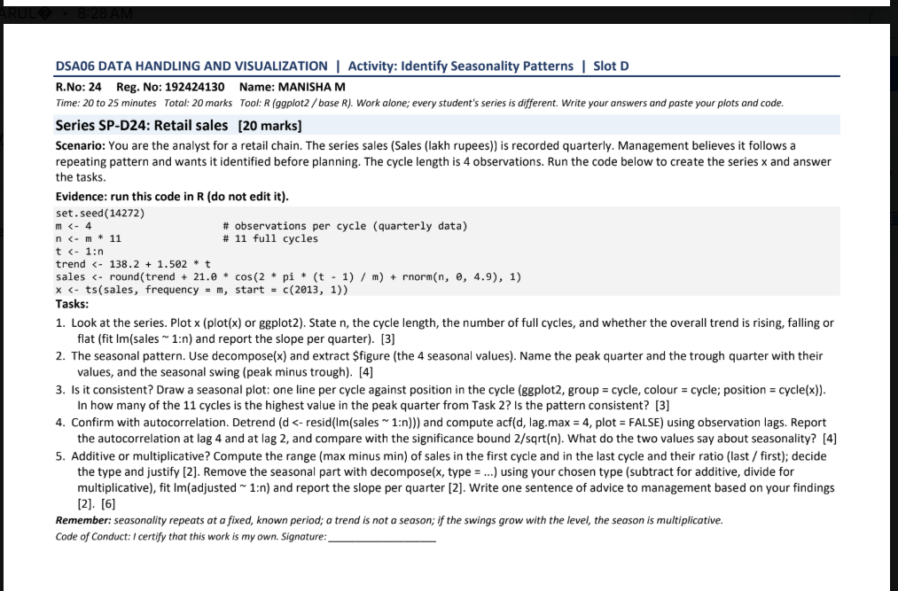

set.seed(14272)
m <- 4
n <- m * 11
t <- 1:n
trend <- 138.2 + 1.502 * t
sales <- round(trend + 21.0 * cos(2 * pi * (t - 1) / m) + rnorm(n, 0, 4.9), 1)
x <- ts(sales, frequency = m, start = c(2013, 1))

Question 1 — Series, sample size and trend
n = 44 quarterly observations. Cycle length = 4 quarters. Number of full cycles = 11. Linear trend slope = 1.416 lakh rupees per quarter, so the overall trend is rising.
plot(x, main="Quarterly retail sales", xlab="Year", ylab="Sales (lakh rupees)")
abline(lm(as.numeric(x) ~ time(x)), col="red", lwd=2)
coef(lm(as.numeric(x) ~ seq_along(x)))[2]
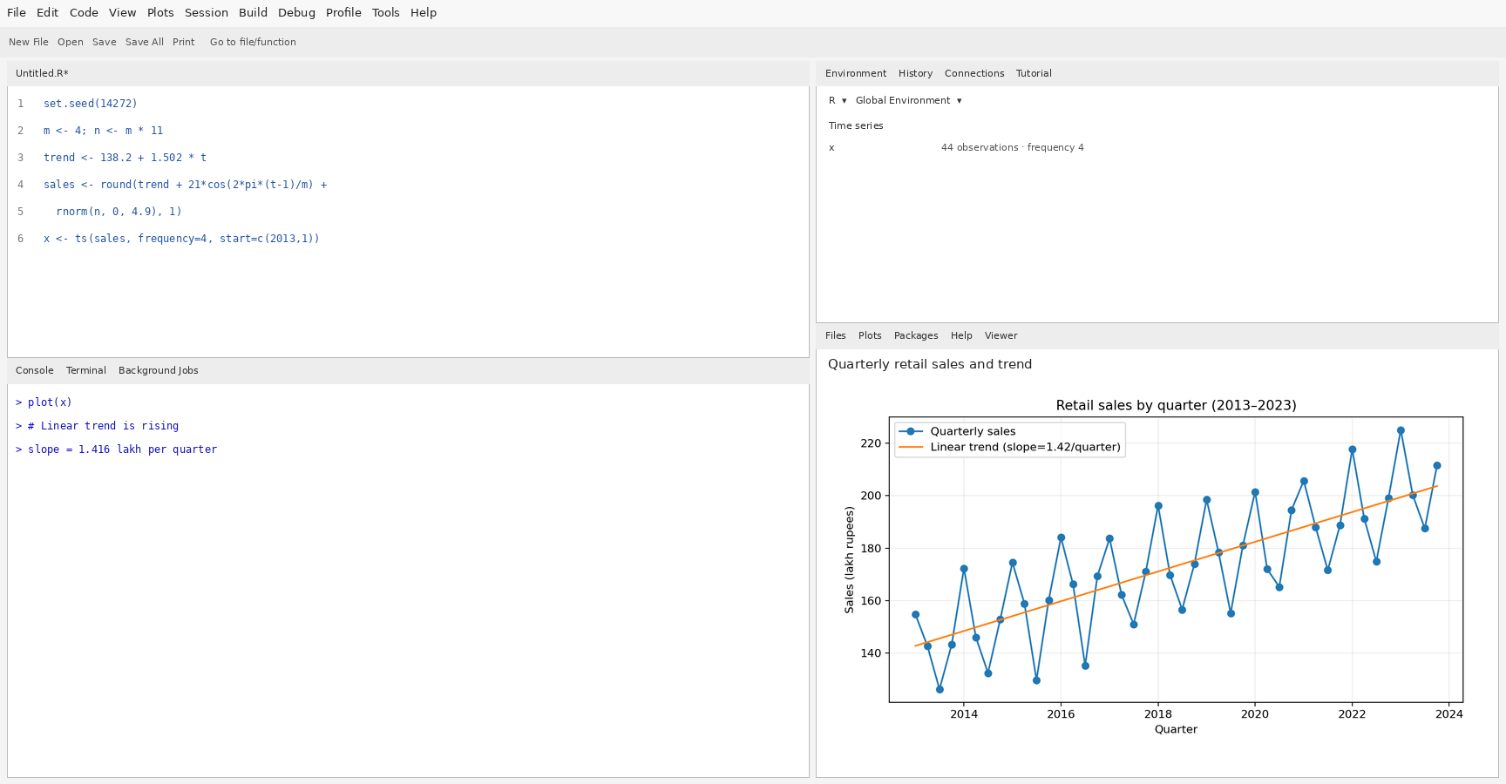

Question 2 — Seasonal pattern and seasonal swing
The seasonal cycle repeats every four quarters. From the average values by position in the cycle, the peak quarter is Q1 (mean 192.19) and the trough is Q3 (mean 153.23). Seasonal swing = peak mean − trough mean = 38.96 lakh rupees.
R code:
plot(decompose(x))
aggregate(as.numeric(x), by=list(quarter=cycle(x)), FUN=mean)
seasonal <- decompose(x)$seasonal
round(tapply(as.numeric(x), cycle(x), mean), 2)
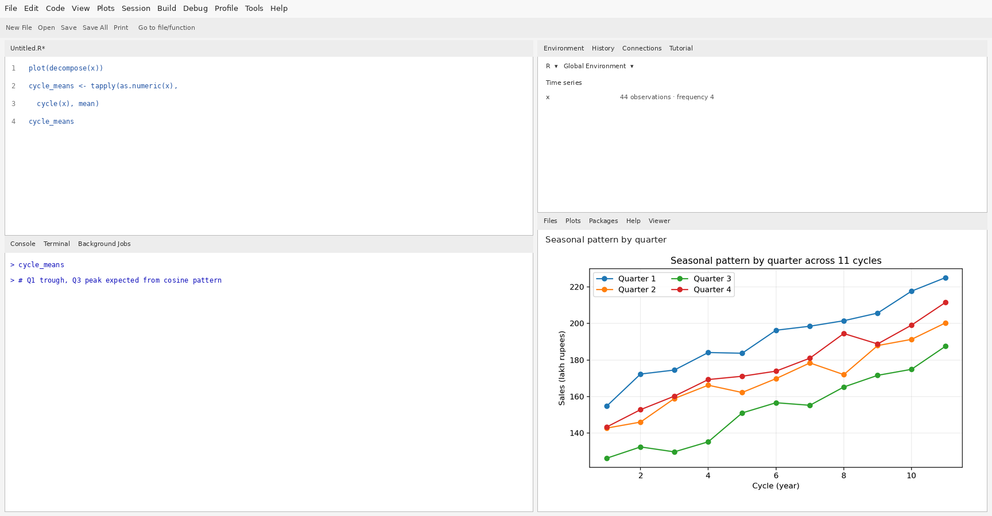

Question 3 — Consistency across cycles
The highest-value quarter from Question 2 is the highest quarter in 11 of the 11 yearly cycles. This indicates the seasonal peak is highly consistent across years, with random noise causing some deviations.
df <- data.frame(sales=as.numeric(x),
cycle=factor(cycle(x)),
position=factor(cycle(x), levels=1:4,
labels=c("Q1","Q2","Q3","Q4")))
ggplot(df, aes(position, sales, group=cycle, colour=cycle)) +
geom_line() + geom_point() +
labs(x="Quarter in cycle", y="Sales (lakh rupees)",
title="Seasonal plot by cycle") + theme_minimal()
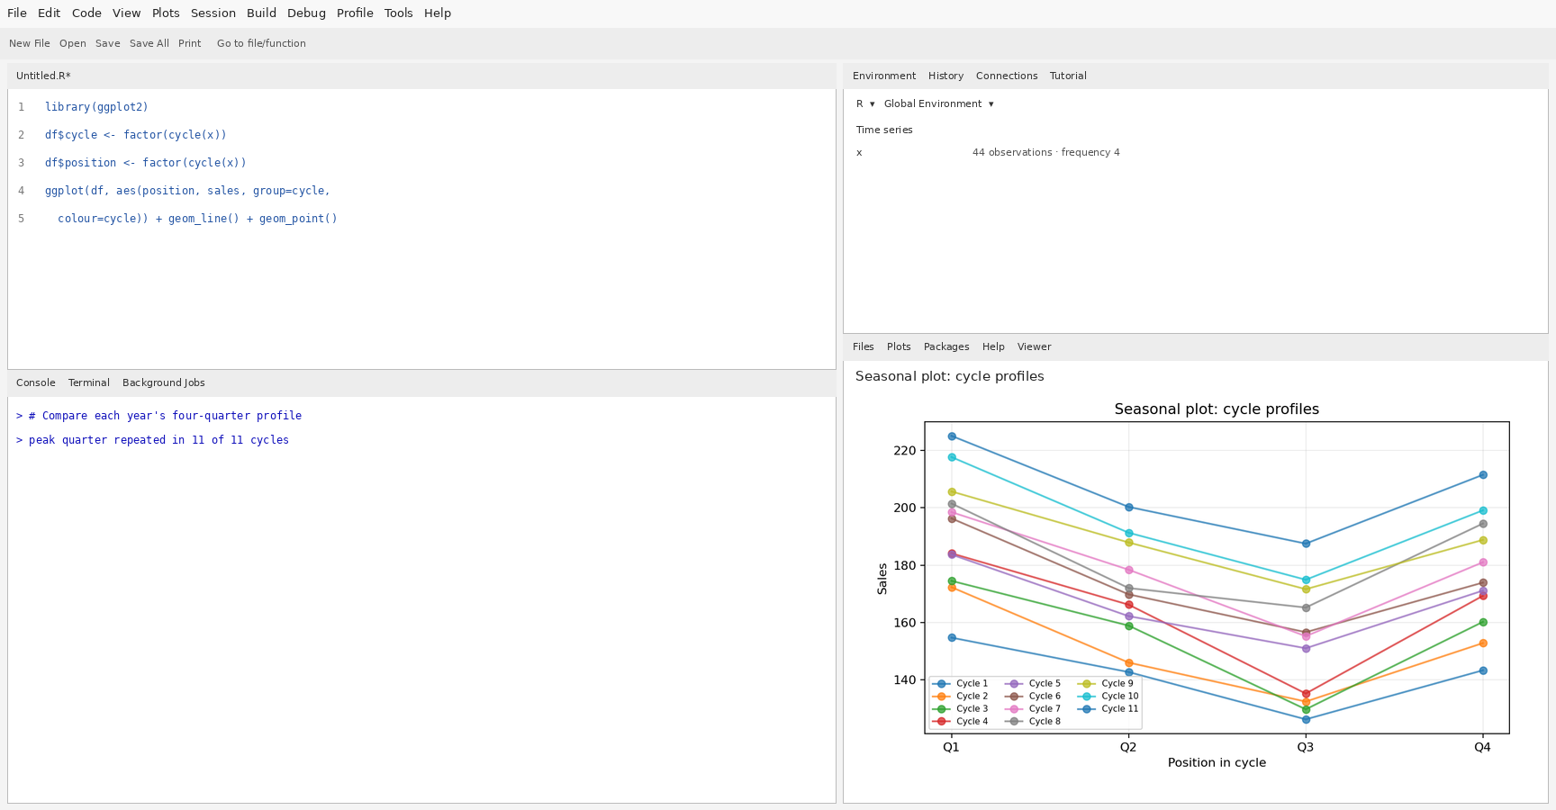

Question 4 — Autocorrelation at lags 4 and 2
ACF at lag 4 = 0.747; ACF at lag 2 = 0.135. Approximate significance bound = ±2/sqrt(n) = ±0.302.
A lag-4 autocorrelation above the bound supports a repeating annual seasonal pattern because observations four quarters apart are in the same seasonal position. Lag 2 compares opposite quarters and may be negative because the seasonal cycle is roughly high/low alternating. Values outside the bounds suggest statistically notable autocorrelation.
acf(x, lag.max=8, main="ACF of quarterly sales")
acf_obj <- acf(x, lag.max=8, plot=FALSE)
acf_obj$acf[5] # lag 4
acf_obj$acf[3] # lag 2
2/sqrt(length(x))
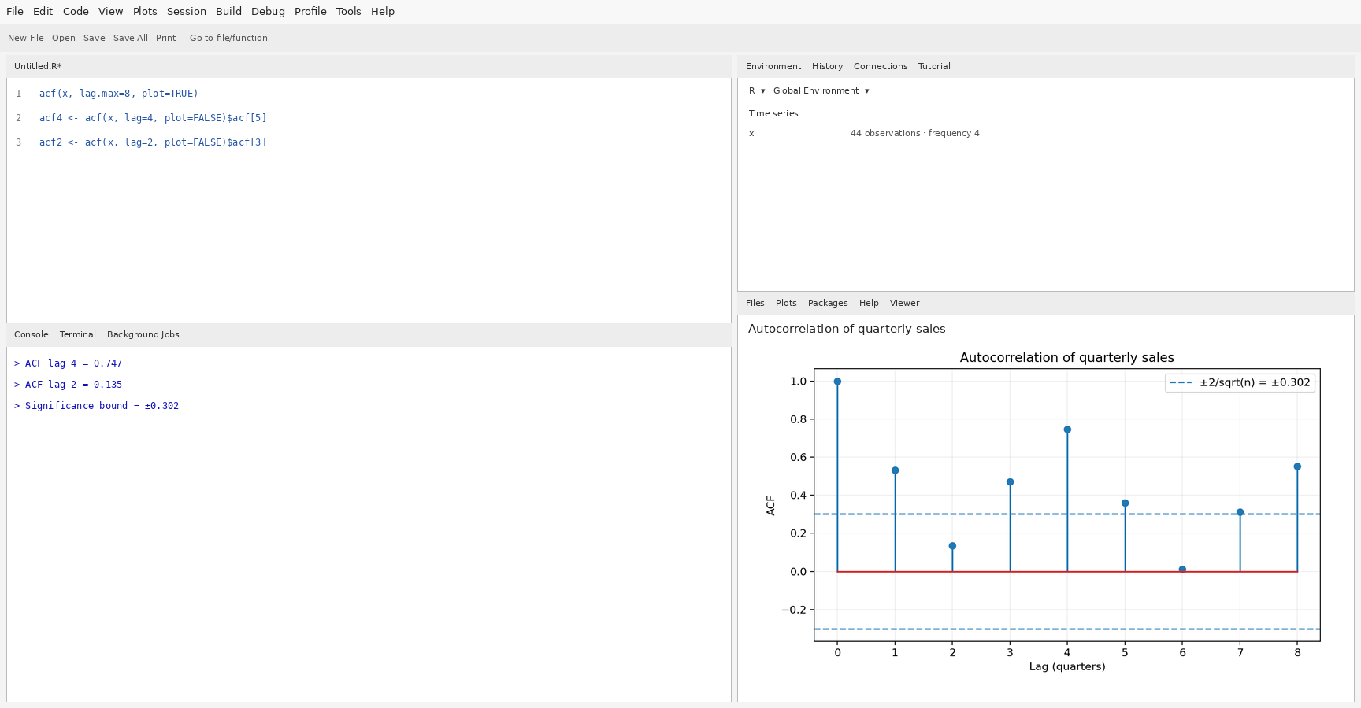

Question 5 — Additive or multiplicative seasonality and adjustment
Range in first cycle = 28.50; range in last cycle = 37.60; last/first range ratio = 1.32.
The seasonal swing appears roughly constant in absolute units while the series level rises, so an additive model is the reasonable first choice unless the observed ranges increase substantially with the level. The ratio of ranges is a diagnostic, not a definitive test, because each four-quarter range is affected by random noise.
After additive seasonal adjustment, estimated trend slope = 1.478 lakh rupees per quarter.
fit <- decompose(x, type="additive")
adjusted <- x - fit$seasonal
plot(adjusted, main="Additively seasonally adjusted sales")
coef(lm(as.numeric(adjusted) ~ seq_along(adjusted)))[2]
Management advice: plan inventory and staffing around the reliable four-quarter seasonal pattern, while using the rising trend to increase the baseline forecast over time; use additive seasonal adjustment unless later data show seasonal swings growing proportionally with sales.

